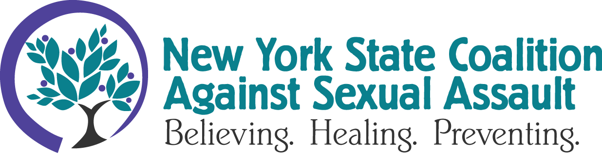
FOR IMMEDIATE RELEASE
DECEMBER 1, 2023
Contact: Anna Woodworth, Communications Director, awoodworth@nyscasa.org, 518-917-2468

Standing with Adult Survivors: Advocates Commit to Continue Non-Violence Work
TROY, NY - The final day of New York State’s Adult Survivors Act, which expired Thanksgiving Day, saw a surge of claims alleging sexual violence in New York State. The year-long act temporarily suspended the statute of limitations and allowed survivors who had experienced sexual violence when they were over the age of 18 to file claims against perpetrators and institutions that were complicit with abuse. The New York State Coalition Against Sexual Assault (NYSCASA) honors the more than 2,500 survivors who filed claims over the past 12 months and calls upon legislators to consider further support for survivors and victims of sexual violence.
Although some of the most recent claims filed were against well-known figures, the majority of claims filed over the past year were against lesser-known people and institutions, such as corrections and medical facilities. Regardless of who the claim was filed against, the ASA empowered survivors to seek justice and accountability from those who caused harm. A pivotal point in any healing journey.
William Rivera, interim executive director of NYSCASA, notes that “sexual violence has a long trail, and some survivors may take time to process their trauma. In addition, an individual thinking about fighting a powerful person or organization may need significant financial support and legal expertise in order to pursue justice. These barriers prevent many survivors from coming forward during that typical window of statute of limitations.”
Forcing survivors to comply with an arbitrary time frame to seek civil justice is not only detrimental to survivor autonomy and healing but also falls outside the scope of trauma informed, victim-centered best practice. NYSCASA envisions a New York that works for all survivors of sexual assault. We will continue to advocate to dismantle barriers and create more accessible avenues for survivors to seek healing and justice.
Rape, sexual assault, and other forms of sexual violence are not limited to any field, culture, or identity: if you or someone you know is a survivor/victim of sexual violence, please reach out to a local rape crisis center. Find your local rape crisis center at NYSCASA’s website.
NYSCASA’s mission is to end all forms of sexual violence and exploitation, and to address the impacts of sexual assault. NYSCASA is a non-governmental, non-profit coalition of community-based rape crisis programs located throughout New York State. NYSCASA strengthens responsive services for all sexual assault victims/survivors and works to increase effective sexual violence prevention efforts.
###

