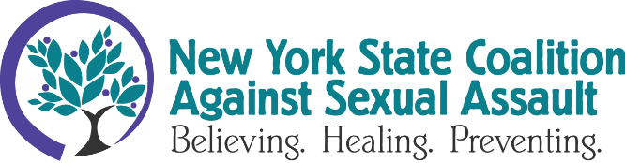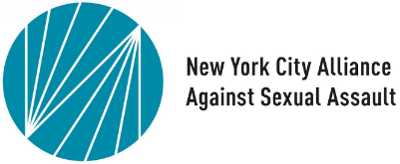

Non-Violence Advocates Respond to Media Coverage of Failures to Handle Sexual Assault Cases
FOR IMMEDIATE RELEASE
DECEMBER 6, 2023
Contact: Anna Woodworth, Communications Director, awoodworth@nyscasa.org; Communications Lead, Jessica Truncali, jtruncali@svfreenyc.org

TROY, NY & NEW YORK, NY - As horrific tales of unprocessed rape kits and mistreatment by hospitals and law enforcement in New York City once again make headlines, the New York State Coalition Against Sexual Assault (NYSCASA) and the New York City Alliance Against Sexual Violence (the Alliance) stand with survivors/victims in full support of the ongoing investigation by the federal Department of Justice (DOJ) into systemic issues at the New York City Police Department’s Special Victims Unit.
The DOJ investigation opened in June 2022, in response to a written request by a group of victims/survivors. Since then, new legislation requiring more responsive organization of rape kits has led to the discovery of mismanaged and misplaced kits. The investigation remains ongoing.
As these issues come into the light of day, NYSCASA and the Alliance note that the problems are systemic and thus the solution must be systemic. Executive Director Emily Miles of the Alliance points out: “We know that a large number, more than half, of all sexual assaults and instances of sexual violence go unreported. The reporting process is retraumatizing on many levels, and that is something we should address systemically.” Interim Executive Director of NYSCASA Will Rivera adds: “Communities of color, immigrant and refugee victims/survivors, and LGBTQIA+ communities are less likely to report their victimization, access supportive services, and receive sexual assault exams, despite experiencing sexual violence at higher rates than white, cis-gender-survivors. The systemic issues go beyond language, culture, and socioeconomic barriers and have their roots in cultural biases and misunderstandings that the non-violence community is working to address.”
NYSCASA and the Alliance offer a variety of support for victims/survivors. Both organizations advocate for legislative support and education, violence prevention, and healing for all victims/survivors. Rape, sexual assault, and other forms of sexual violence are not limited to any field, culture, or identity: if you or someone you know is a survivor/victim of sexual violence, please reach out to a local rape crisis center. Find your local rape crisis center at NYSCASA’s website.
NYSCASA’s mission is to end all forms of sexual violence and exploitation, and to address the impacts of sexual assault. NYSCASA is a non-governmental, non-profit coalition of community-based rape crisis programs located throughout New York State. NYSCASA strengthens responsive services for all sexual assault victims/survivors and works to increase effective sexual violence prevention efforts.
The New York City Alliance Against Sexual Assault (The Alliance) works to prevent sexual violence and reduce the harm it causes through education, prevention programming, advocacy for survivors, and the pursuit of legal and policy changes. The Alliance was founded in 1999 by rape crisis centers in New York City in order to advocate for the needs of survivors and the organizations that serve them.
###

