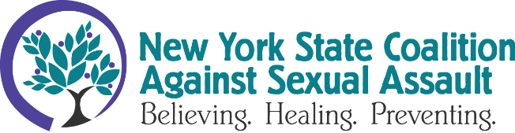
FOR IMMEDIATE RELEASE
JANUARY 29 2024
Contact: Anna Woodworth, Communications Director, awoodworth@nyscasa.org, 518-917-2468

E. Jean Carroll’s Courage Lauded by Advocates
TROY, NY - The federal jury’s ruling awarding millions to writer E. Jean Carroll in her civil defamation case against former president Donald Trump on Friday marks a victory for survivors everywhere. The jurors awarded Carroll a combined $83.3 million dollars ($65 million in punitive damages and $18.3 million in compensatory damages) for Trump’s defamatory statements regarding Carroll, which led to threats, suffering, and reputational harm.
E. Jean Carroll was one of the first to file under the Adult Survivors Act of the nearly 3,000 survivors that filed between November 2022 and November 2023. The ASA allowed Carroll to pursue justice for the 1996 assault 28 years later in 2023, a process which began with Carroll courageously sharing her story in her 2019 memoir.
While this case unfolded in front of a huge audience due to the well-known figures involved, its hallmark features are shared with many sexual assault cases. The person causing harm often holds authority over their victim; the survivor waits years to share their story; and the person causing harm’s defense rests on the survivor’s alleged benefit from making the accusation. We know that many survivors take years or decades to bring their experiences to light, and that survivors rarely walk away from the arduous process of speaking their truth to power with more than what they had prior to the assault. E. Jean Carroll’s bravery in pursuing justice not only in 2024 but in 2023, 2022, and 2019 in the face of Trump’s repeated defamation and subsequent threats is remarkable.
Notably, Carroll shared her story with two of her friends immediately after the assault. Carroll sometimes blamed herself for what had happened. The writer initially chose not to pursue justice due to the fear of the repercussions she might endure at the hands of a man with significantly more power than her. But sharing her story did more than lay the groundwork for Carroll’s case decades later. It also supports what advocates in the sexual violence field suggest: a survivor sharing their story with a trusted person soon after their assault can be a beneficial first step in their healing journey. To see justice served to one of the most powerful individuals in the country brings hope to each victim, survivor, and advocate in the United States.
If you or someone you know is a survivor of sexual violence, please reach out to a local rape crisis center. Find your local rape crisis center at NYSCASA’s website.
NYSCASA is a statewide membership organization providing support to 80+ community-based rape crisis programs located throughout New York State.
# # #

